PROJECT AND TEAM INFORMATION

Project Title
Agentic Compiler

Student / Team Information
Team Name: | Code Compilers
Team member 1 (Team Lead)  Name: Adityakeerti  University Roll Number: 2318236  Student ID: 230111444  Email: adityaanurag461@gmail.com | 
Team member 2  Name: Megha Singh  University Roll Number: 2319107  Student ID: 23012865  Email: meghajarodiya@gmail.com | 
Team member 3  Name: Sameer Panwar  University Roll Number: 2319494  Student ID: 230115087  Email: panwarsameer121@gmail.com | 
Team member 4  Name: Vridhi Pundir  University Roll Number: 2319888  Student ID: 230122422  Email: vridhipundir4@gmail.com | 

PROPOSAL DESCRIPTION (10 pts)

Motivation (1 pt)
Programming languages today either prioritize strict structure (like C/C++) or ease of use (like Python), but rarely combine both effectively. Beginners often struggle with complex syntax, cryptic compiler errors, and rigid grammar rules. Traditional compilers simply stop at error detection without helping users fix the issue intelligently.
The motivation behind this project is to design a structured programming language that combines C-like control flow and block structure with Python-like simplicity in syntax. On top of that, we aim to build an intelligent compiler that does more than error detection — it actively assists in error correction using a Reinforcement Learning (RL) based policy trained on code–error–solution datasets.
This “Agentic Compiler” will not only perform lexical, syntactic, and semantic analysis but will also iteratively refine code by suggesting and applying corrections until compilation succeeds. This reduces development friction, improves learning for beginners, and demonstrates how compiler design can be augmented with learning-based agents.
The project bridges classical compiler theory and modern AI-based decision systems, making it both academically rigorous and practically innovative.

State of the Art / Current solution (1 pt)
(Describe how the problem is solved today (if it is). Max 200 words).
Traditional compilers such as GCC and Clang strictly follow the phases of lexical analysis, parsing, semantic analysis, and code generation. They report errors but do not attempt automated correction.
Modern IDEs provide limited error suggestions using rule-based heuristics. AI-based tools like GitHub Copilot rely on large language models to generate or fix code, but they operate externally and are not tightly integrated with compiler internals.
Research in automated program repair uses machine learning or reinforcement learning to fix bugs, but these systems typically work on existing languages rather than being embedded into a compiler architecture.
This project differs by integrating a learning-based correction agent directly into the compilation pipeline, creating a closed feedback loop between compiler diagnostics and intelligent correction.

Project Goals and Milestones (2 pts)
(Describe the project general goals. Include initial milestones as well any other milestones. Max 300 words).
Goals:
- Design a new structured programming language combining:
  - C-like loops and block scoping
  - Python-like simplified syntax (e.g., simplified print statements)
- Implement a compiler in Java with:
  - Lexer
  - Parser
  - Semantic Analyzer
  - Intermediate Code Generator
- Create a dataset of:
  - Code
  - Error type
  - Error location
  - Corrected solution
- Train a Reinforcement Learning policy to:
  - Identify error patterns
  - Suggest corrective actions
- Integrate the RL policy into an Agent Pipeline that:
  - Receives compiler errors
  - Applies corrections
  - Recompiles iteratively until resolved
Milestones:
Milestone 1: Language Design & Core Compiler Development
- Define formal grammar (EBNF).
- Implement Lexer (tokenization).
- Implement Parser and generate AST.
- Implement Semantic Analyzer (type checking, scope validation).
- Generate Intermediate Representation (IR).

Milestone 2: Dataset Creation & Error Modeling
- Collect and generate syntactic and semantic errors.
- Create structured dataset:
(Code, Error Type, Error Location, Corrected Code).
- Develop synthetic error generation pipeline.
- Categorize common compiler error patterns.

Milestone 3: RL Policy Training
- Define RL framework:
  - State: Compiler error + token context.
  - Action: Code modification operation.
  - Reward: Successful compilation.
- Train RL policy using iterative correction episodes.
- Evaluate correction accuracy and convergence.

Milestone 4: Agent Integration & System Evaluation
- Integrate RL agent into compiler pipeline.
- Implement iterative compile–fix–recompile loop.
- Measure:
  - Error correction success rate
  - Compilation efficiency
  - Improvement over baseline compiler
- Final system testing and documentation.

Project Approach (3 pts)
(Describe how you plan to articulate and design a solution. Including platforms and technologies that you will use. Max 300 words).
The project will be implemented primarily in Java, combining classical compiler design with a Reinforcement Learning–based correction agent.

Phase 1 – Language Design & Compiler Construction
First, a new structured programming language will be formally defined using EBNF grammar. The language will combine C-like structured control flow (loops, conditionals, block scoping) with simplified Python-style syntax for ease of use.
The compiler will be implemented in Java and will include:
- Lexical Analyzer (tokenization)
- Parser (recursive descent)
- Abstract Syntax Tree (AST) generation
- Semantic Analyzer (type checking, scope validation)
- Intermediate Representation (IR) generation
This phase results in a fully working baseline compiler capable of detecting lexical, syntactic, and semantic errors.

Phase 2 – Error Dataset Creation & RL Policy Training
A structured dataset will be developed containing:
- Source code
- Error type
- Error location/token
- Corrected solution
Synthetic incorrect programs will be generated to expand coverage of common error patterns.
A Reinforcement Learning framework will then be defined:
- State: Compiler error message + token context
- Action: Code modification operation
- Reward: Successful compilation
The RL policy will be trained using iterative correction episodes until it learns effective repair strategies.

Phase 3 – Agentic Compiler Integration & Feedback Loop
The trained RL policy will be integrated into an Agent Pipeline.
Workflow:
- Compile source code.
- If error detected, send error context to RL agent.
- Apply predicted fix.
- Recompile.
- Repeat until resolved or maximum iterations reached.
This creates a closed feedback-driven intelligent compilation system that moves beyond error detection to automated correction.

System Architecture (High Level Diagram)(2 pts)
(Provide an overview of the system, identifying its main components and interfaces in the form of a diagram using a tool of your choice).
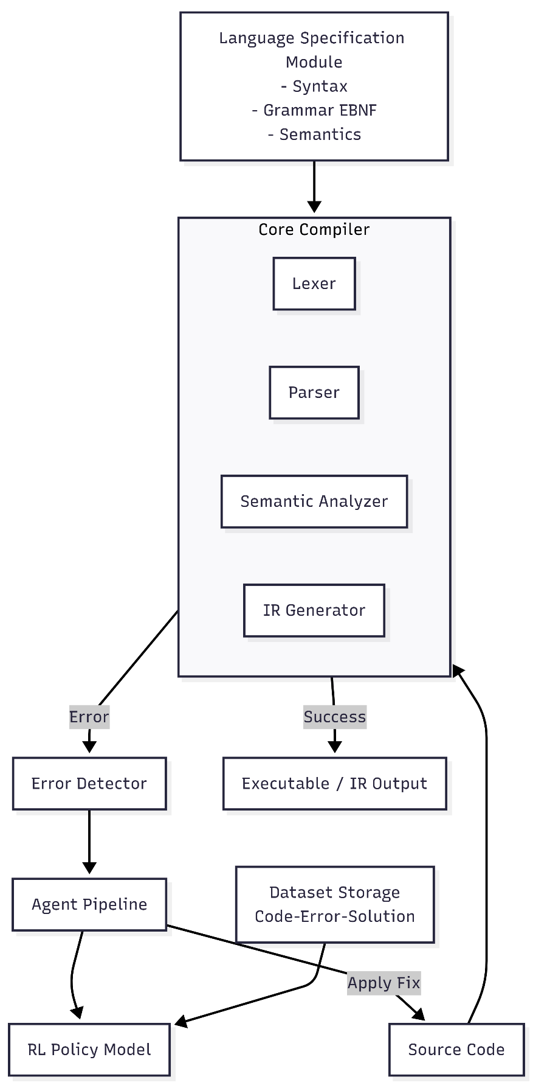

Project Outcome / Deliverables (1 pts)
(Describe what are the outcomes / deliverables of the project. Max 200 words).
- A new structured programming language specification.
- Fully working Java-based compiler.
- Abstract Syntax Tree and intermediate representation support.
- Code–error–solution dataset.
- Trained Reinforcement Learning model.
- Integrated Agentic Compiler capable of iterative self-correction.
- Evaluation report comparing:
  - Error detection rate
  - Correction success rate
  - Compilation efficiency

Assumptions
- The language scope will be limited to core programming constructs (variables, loops, conditionals, functions).
- RL model will focus on syntactic and common semantic errors.
- Dataset size will be manageable within project constraints.
- Computational resources are sufficient for training a moderate-sized RL model.
- The compiler will initially target intermediate code instead of full machine code.

References
(Provide a list of resources or references you utilised for the completion of this deliverable. You may provide links).
1. Aho, A. V., Lam, M. S., Sethi, R., & Ullman, J. D.
Compilers: Principles, Techniques, and Tools (2nd Edition).
Pearson, 2006.
2. Mnih, V., Kavukcuoglu, K., Silver, D., et al.
“Human-level control through deep reinforcement learning.”
Nature, 518(7540), 529–533, 2015.

